Used Book Sharing System

Vision Document

Version 1.7

Revision History

|  |  |  |  |
| --- | --- | --- | --- |
| **Date** | **Version** | **Description** | **Author** |
| 03/11/2019 | 1.0 | Fill 1. Introduction & 2. Positioning | Bui Quang Thang |
| 03/11/2019 | 1.1 | Fill 3.1 Stakeholder summary & 3.5 Alternatives and competitions | Tran Thuan Thanh |
| 04/11/2019 | 1.2 | Fill 4. Product overview & 5. Product features | Bui Quang Thang |
| 04/11/2019 | 1.3 | Fill 3.2 User summary | Dang Duc Trung |
| 05/11/2019 | 1.4 | Fill 3.4 Summary of Key Stakeholder and User Needs & Edit 3.2 User summary | Dang Duc Trung |
| 05/11/2019 | 1.5 | Fill 3.3 User environment & 6. Non-functional requirements & update 5. Product features | Bui Quang Thang |
| 10/11/2019 | 1.6 | Edit 3.1 stakeholder summary & 3.2 user summary & 3.4 key user/stakeholder needs | Bui Quang Thang |
| 10/11/2019 | 1.7 | Review all sections and edit font/color text,…  Add examples from Thuan Thanh to 3.5 alternatives and competitions | Bui Quang Thang |

Table of Contents

1. Introduction 3

1.1 References 3

2. Positioning 3

2.1 Problem Statement 3

2.2 Product Position Statement 3

3. Stakeholder and User Descriptions 3

3.1 Stakeholder Summary 3

3.2 User Summary 3

3.3 User Environment 3

3.4 Summary of Key Stakeholder or User Needs 3

3.5 Alternatives and Competition 3

4. Product Overview 3

4.1 Product Perspective 3

4.2 Assumptions and Dependencies 3

5. Product Features 3

6. Other Product Requirements 3

Vision (Small Project)

# Introduction

The introduction of the **Vision** document provides an overview of the entire document. It includes the purpose and references of this **Vision** document.

The purpose of this document is to collect, analyze, and define high-level needs and features of the Used Book Sharing System. It focuses on the capabilities needed by the stakeholders and the target users, and **why** these needs exist. The details of how the Used Book Sharing System fulfills these needs are detailed in the use-case and supplementary specifications.

## References

## [Collegiate Sports Paging System’s Vision, version 1.0](https://sceweb.uhcl.edu/helm/RUP_course_example/courseregistrationproject/indexcourse.htm)

<https://sceweb.uhcl.edu/helm/RationalUnifiedProcess/examples/csports/ex_vision.htm>

1. [Course Registration System’s Vision, version 1.0](https://sceweb.uhcl.edu/helm/RUP_course_example/courseregistrationproject/indexcourse.htm)

<https://sceweb.uhcl.edu/helm/RUP_course_example/courseregistrationproject/indexcourse.htm>

# Positioning

## Problem Statement

|  |  |
| --- | --- |
| The problem of | Buying and selling book by traditional way |
| affects | Readers who need books and People who has so many books. |
| the impact of which is | Readers have to spend a lot of money to buy a new book, although they just need an old book with low price to buy and read.  People who own many used books don’t know the way to share their books or have to pay a very high price to build an book store. |
| a successful solution would be | An online system where people can post information about the books they want to share and readers can search for and get the old books they desire with lower price. |

## Product Position Statement

|  |  |
| --- | --- |
| For | Students, teacher, workers,… |
| Who | Want to share or buy used books. |
| The Used Book Share System | Is a web application. |
| That | Supports sharing used printed book. |
| Unlike | Traditional way of buying and selling books which requires lots of efforts to buy, sell or search for a desired book. |
| Our product | Saves readers time and budget to have a book and helps people share books more easily. |

# 

# Stakeholder and User Descriptions

## Stakeholder Summary

|  |  |  |
| --- | --- | --- |
| **Name** | **Description** | **Responsibilities** |
| Project Manager | Who will manage the team to complete the project. | Managing the project and the members.  Supervise the team member's work. |
| Developing Team | Work to complete the project from developing to testing. | Design, implement, testing, etc. |
| Customer | Who will make the order to make the system. | Specifies the requirements. |
| Readers | Who will use the system to find desired books. | Use the system. |
| Merchant | Who will use the system to offer their used books to community. | Use the system. |
| Administrator | Who will gain authority to manage the system when the system is in use. | Use the system. |

## 

## User Summary

|  |  |  |  |
| --- | --- | --- | --- |
| **Name** | **Description** | **Responsibilities** | **Stakeholder** |
| Merchant | Upload book’s information and their contact information | Use the website to sell used books. | Self-represented |
| Readers | Search for books and contact information of merchant who have reader’s desired books. | Use website to seek and contact merchant to buy used books. | Self-represented |
| Administrator | Prevent the illegal actions in website. | Ensure website don’t have the illegal actions. | Self-represented |

## User Environment

## Readers and merchants will be expected to have a browser-enabled device for visiting our web page and using features.

Administrator is also required to have a browser-enabled device for checking issues and preventing bad users.

A browser-enabled device includes mobile phone or personal computer with a browser installed and Internet connected.

## Summary of Key Stakeholder or User Needs

|  |  |  |  |  |  |
| --- | --- | --- | --- | --- | --- |
| **Need** | **Priority** | **Concerns** | **Current Solution** | **Proposed Solutions** | |
| Search for books | High | Response time and relation of result books to search key. | Readers have to traverse all used book groups or stores to find the book they need. | | Using online website to provide an area for users to upload used books, so readers can find books more easily whenever they demand. |
| Upload information about books which user intend to sell. | High | Credit level of merchant | In sharing used books group such as Facebook’s group, the book’s information is usually not fulfilled and merchant and reader must contact to verify about the book’s status. | | Provide a form before uploading book and merchants have to fulfill this form. This information will be used to rate merchant’s credit level. |
| Manage offering books | High | Ability to manage products | None | | Provide for merchant list of offering books along with tools such as edit, delete to manage all books which they uploaded. |
| Rate and comment on books to increase or decrease merchant’s credit. | Medium | Credit level of merchant | None (Reader can’t know about the merchant credit because product is used book.) | | Provide ‘comment’ and ‘rating’ features for book/merchant to other readers can know about the quality of this book/merchant. |
| Register and receive notification when a desired book available. | Medium | Have favorite book as soon as possible | None | | Check new uploaded books and send notification to reader when the book they are waiting available. |
| Delete posts or block merchant. (administrator’s need) | Medium | Ensure benefit for user | None | | Provide vote/rate feature, feedback feature for all users. Administrator can base on feedback and ratings to prevent bad users. |

## Alternatives and Competition

|  |  |
| --- | --- |
| **Alternatives and competitors** | **Strengths/Weaknesses** |
| Big bookstore where users can refund their books  Example: Nguyễn Văn Cừ Bookstore | Higher price because the book have to go through the shop. Books are keep in better conditions. |
| Other old book store websites  Example: [BookFinder.com](http://bookfinder.com/" \t "https://app.slack.com/client/TPJT5V2T0/_blank) | May be only popular in foreign countries and only have books in certain languages. Need to be shipped oversea. |
| Physical old bookstores  Example: Cửa Hàng Sách Cũ Tổng Hợp 160, Phu Nhuan District | Take time to come to the bookstore, hard to find the book you need. |
| Facebook, Twitter or any social media where people can post their old books to sell.  Example: Mọt sách giấy: 33k members Mua bán sách cũ Online - TPHCM 13K members | Fast, convenient, full-features such as messaging, commenting. Lack of rating for users, book categorization and favourite sellers features. |

# Product Overview

## Product Perspective

Used Book Sharing System is a web application. It is self-contained and can be accessed through browser as below:

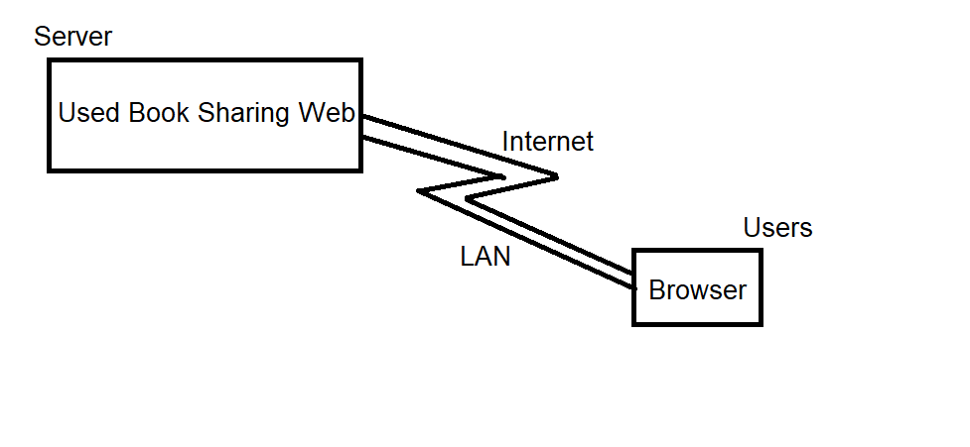

## Assumptions and Dependencies

- It is assumed that almost user’s browsers supports our web application (html, css, javascript, nodejs, php,…).

- It’s assumed that there is an appropriate server for us to deploy our web application. If not, our application can be only accessed through LAN.

- It’s assumed that we have enough time and technique skills to fulfill our product’s requirements.

# Product Features

## Visit web pages

Used Book Sharing Web must be opened to visit without logging in. The home page represents main features such as Create account, Log in, Search books, Offer books, List of featured books,…

## Create account

Users can create accounts to use more features. Users provide needed information and confirm policy to request a new account. The system validates and informs user that new account was created. If something’s wrong, system shall notify users immediately.

## Log In

User provides username and password to log in into website. If success, user will be redirected to main page with account logged in. Otherwise, a notification will show up to notify user about what was wrong.

## Search for books

User provides the name (or type, author, ..) of the book that he/she desires. System responses by showing list of the books matched with provided information.

## Offer book

Users are required to log in before using this feature.

System enables users to offer their book to community. Users have to provide needed information about books such as some images of book along with their contact to offer.

## Manage offering books

Users are required to log in before using this feature.

System allows users to see their offering books and some options such as: edit, delete.

### Edit offering book

System represents the information of the book and enables user to edit then confirm changes.

### Delete offering book

The system enables users to delete books from their offering book list when their books are not available to share.

## View book’s details

System enables users to view details of a book such as name, type, author, date public, poster email, ratings, comments.

## Post comment

When viewing a book’s detail, users can post their comment about book to demonstrate their opinions. They can either provide their information and comment or just leave a comment.

## Rate book

When viewing a book’s detail, users can rate stars to assess that book.

## Manage account

Users can change their profiles, avatar or password as they needs.

## Notifications

Users shall be notified when someone comments or rates on their books. They also informed if their comments on certain book are replied. Or they can receive notifications from system about important information.

5.12 Administrator

Some authorized people can gain administrator level and are responsible for checking issues such as misleading posts, havoc users and preventing those as soon as possible.

5.13 Report & Send feedback

Users are required to log in before using this feature.

If user realizes an ambiguous behavior from another user, they can create a report about bad users and send it to System. Administrator will receive and carry out appropriate operations.

Or if users have a way to improve our system, they are welcome to send feedback, their contributions will have our respects.

5.14 Wish list

Readers who are interested in some kinds of book or a particular book can provide their inspired book’s information in their Wish list. The system will notify them as soon as their desired books available.

# Non-Functional Requirements

1. Environment requirement

Personal computer or mobile device with an updated browser and Internet connection.

1. Hardware requirement

Not defined

1. Visit website

Home page must have a clear visible theme and have to be easy to use.

1. Create account

User needs to confirm website policy before heading to create a new account.

1. Login

Username and password need to be encrypted before being sent over Internet.

User must be prevented from logging in for a certain time after many failed logging in.

1. Search for books

The time for searching for a book needs to be within 5 seconds. Result books have to be sorted by descending related order (most related book to least related book).

1. Offer book

When offering a book, users must provide key information such as book’s name and contact email. Email must be valid also.

1. Edit & delete

There is notification from system to tell users about success of operations such as Edit, delete then prompt them to reload page to see updated contents.

1. Book details

Book details must be placed at the center of screen and easy to see at least images of book and contact section.

1. Comment

Users’ comment is not longer than 200 characters.

1. Rating

Rate method must be one step and easy to complete such as clicking to number of stars.

1. Manage account

When changing password, user must provide correct old password before changing into new password.

1. Notifications

User can choose notification method according to their need.

1. Administrator

Administrator must be usually a person from system. Administrator must inform users about their bad behavior before doing operations such as delete post or block user.

1. Design constraint

Not defined

1. Specific documentation requirements

Not defined